**Project Design Phase – II**

**Technology Architecture**

|  |  |
| --- | --- |
| **Date** | 29 October 2022 |
| **Team ID** | PNT2022TMID33222 |
| **Project Name** | Smart Solutions for Railways |
| **Marks** | 4 Marks |

**Technical Architecture:**

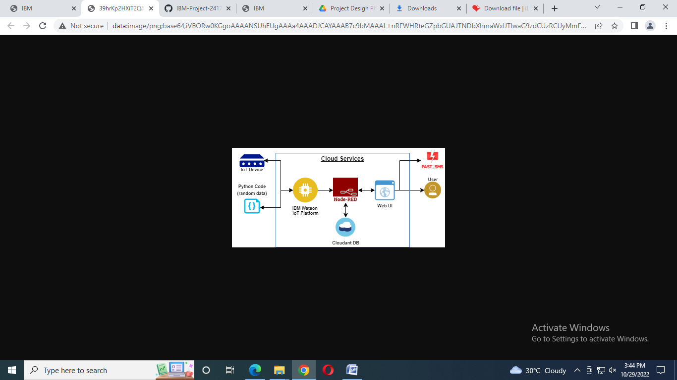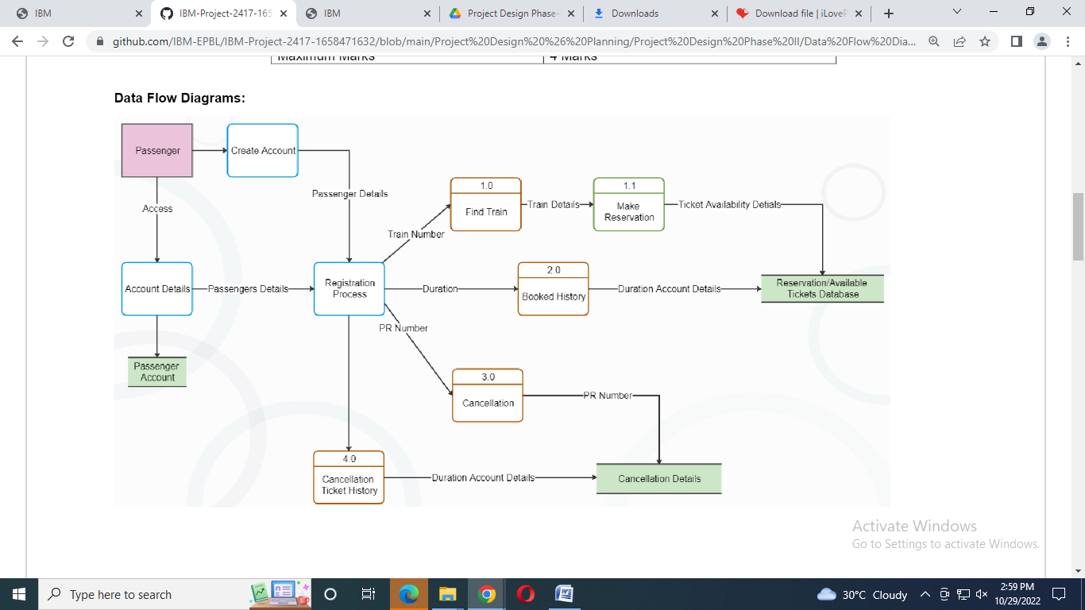

**Table 1: Components & Technologies:**

|  |  |  |  |
| --- | --- | --- | --- |
| **S.no** | **Component** | **Description** | **Technology** |
| 1 | User Interface | How user interacts with application.  e.g. Web UI, Mobile app, Chatbot etc., | MIT App Inventor, React |
| 2 | Application Logic-1 | Logic for a process in the application | Python |
| 3 | Application Logic-2 | Logic for a process in the application | IBM Watson STT service |
| 4 | Application Logic-3 | Logic for a process in the application | Node Red |
| 5 | Database | Data Type, Configuration etc. |  |
| 6 | Cloud Database | Database service on cloud | IBM Cloudant |
| 7 | File Storage | Reservation Details, Live Status of train | IBM Block Storage |

**Table 2: Application Characteristics:**

|  |  |  |  |
| --- | --- | --- | --- |
| **S.no** | **Characteristics** | **Description** | **Technology** |
| 1 | Open-Source frameworks | The Open-source frameworks used. | Python, Node Red, MIT App inventor. |
| 2 | Security Implementation | The security/Access controls implemented, use of firewalls | Password encryption-AES, Password Hash-SHA-512, bcrypt |
| 3 | Scalable architecture | Justification about the scalability of architecture | 3-tier |
| 4 | Availability | Justification about the availability of application | IBM Cloudant |
| 5 | Performance | Design consideration for the performance of the application | IBM Cloudant |